Report

Comparison numerical solution to exact analytical solution.

We figured out that the stiffness and the step size are the most crucial parameter for the behavior of the spring. The experiments containing the borders of instability for each Method.

# Euler:

For the Euler method the parameters have to be very small to have a stable spring-mass-system, especially the step size.

|  |  |  |  |  |
| --- | --- | --- | --- | --- |
|  | 100 | 50 | 30 | 25 |
| 0.001 | unstable | stable | stable | stable |
| 0.002 | unstable | unstable | stable | stable |
| 0.003 | unstable | unstable | unstable | stable |
| 0.004 | unstable | unstable | unstable | unstable |

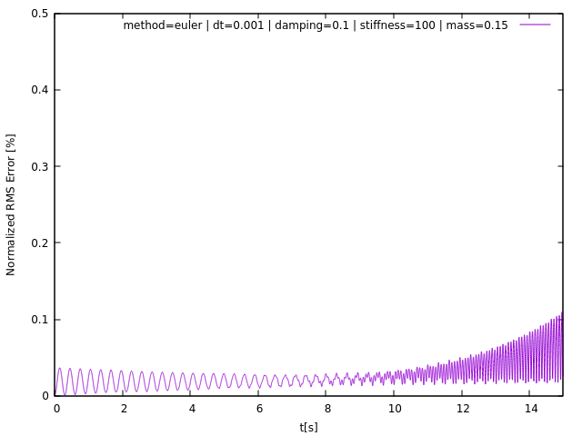

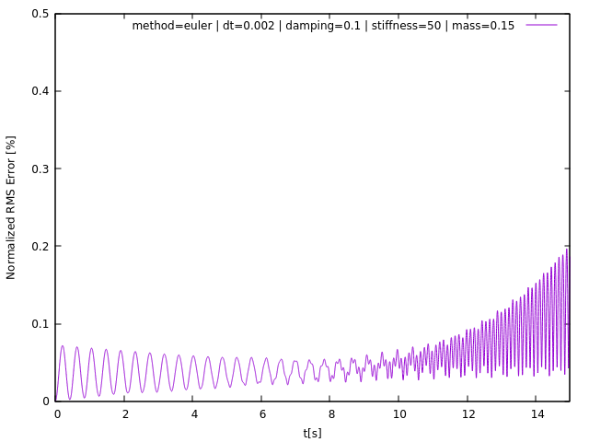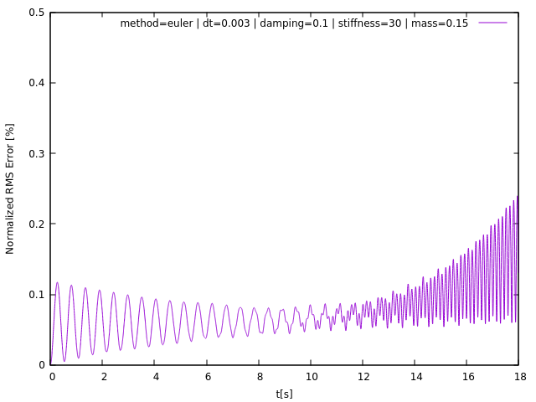

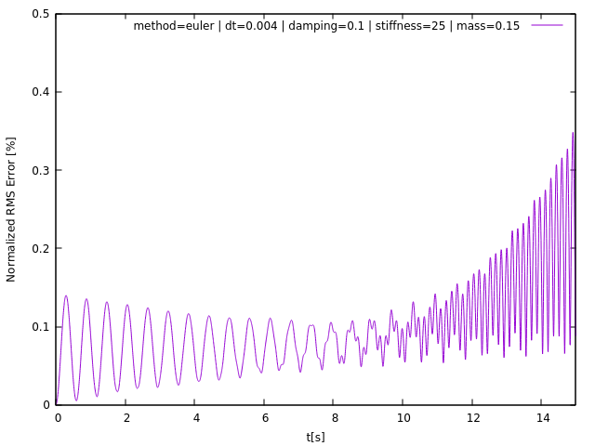

# Symplectic:

Similar to the Euler method the symplectic method is unstable for relatively small parameters.

|  |  |  |  |  |
| --- | --- | --- | --- | --- |
|  | 110 | 80 | 70 | 50 |
| 0.004 | unstable | stable | stable | stable |
| 0.005 | unstable | unstable | stable | stable |
| 0.006 | unstable | unstable | unstable | stable |
| 0.008 | unstable | unstable | unstable | unstable |

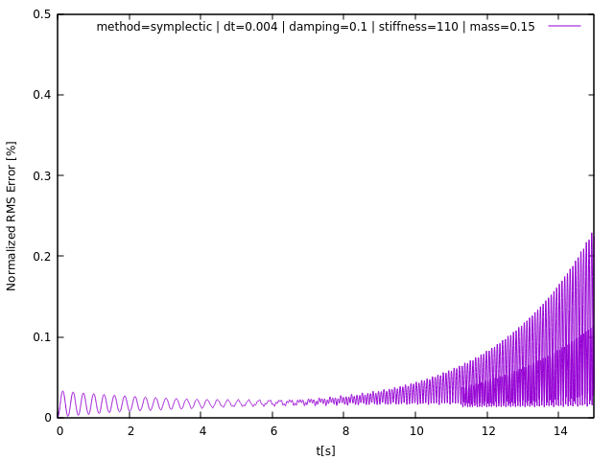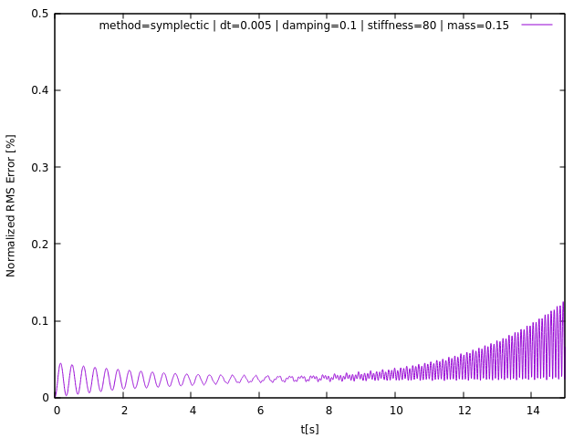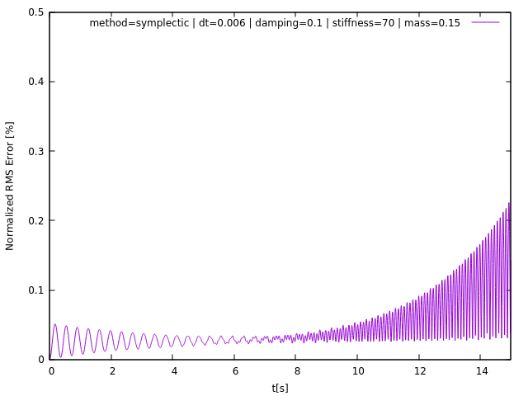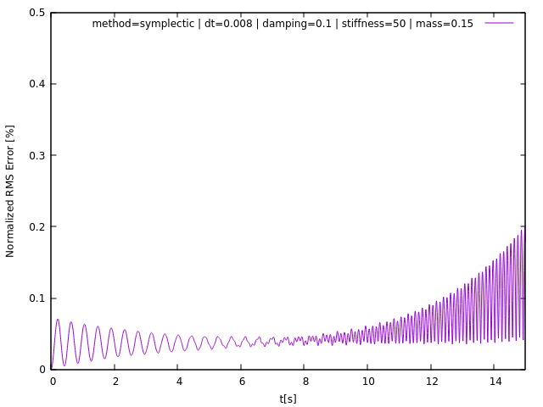

# Leapfrog:

The Leapfrog is pretty stable also at high parameters, interesting is the way the spring behaves when it gets instable. It's also visible in the plot of the RMS Error.

|  |  |  |  |  |
| --- | --- | --- | --- | --- |
|  | 100 | 50 | 35 | 25 |
| 0.01 | unstable | stable | stable | stable |
| 0.015 | unstable | unstable | stable | stable |
| 0.02 | unstable | unstable | unstable | stable |

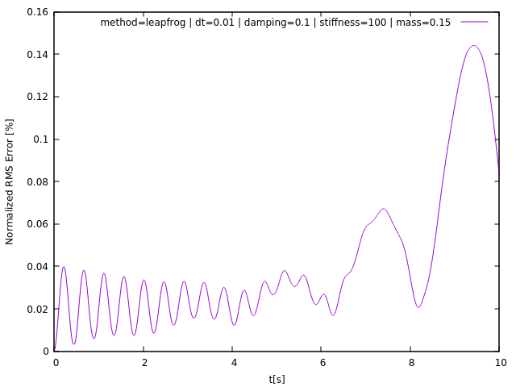

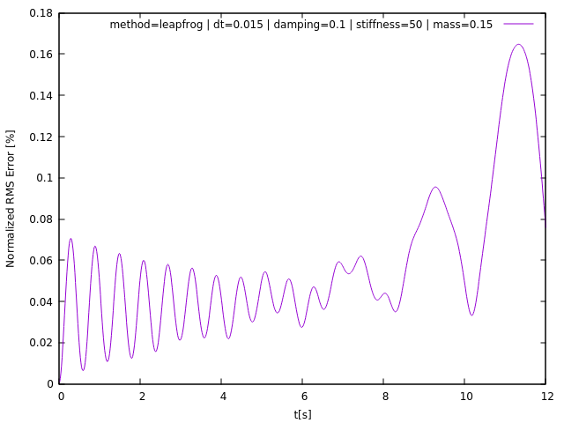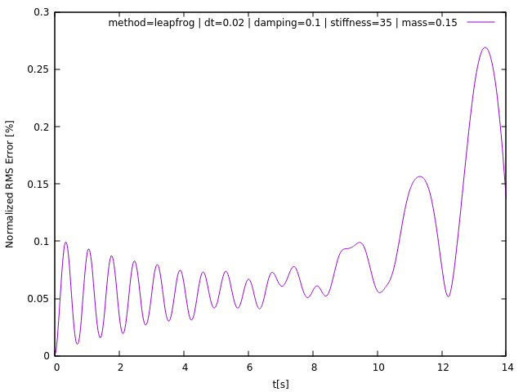

# Midpoint:

The midpoint method had the best results and it was pretty hard to find the instability threshold. Until the step size of 0.045 this method was almost “unbreakable”. The midpoint method don’t crash like the other methods after a few seconds, it crashes immediately after 1 second. With a step size of 0.048 and a stiffness of 190 the spring mass system goes totally crazy just after 1 second.

|  |  |  |  |  |  |
| --- | --- | --- | --- | --- | --- |
|  | 210 | 200 | 185 | 100 | 90 |
| 0.045 | unstable | stable | stable | stable | stable |
| 0.046 | unstable | unstable | stable | stable | stable |
| 0.048 | unstable | unstable | unstable | stable | stable |
| 0.065 | unstable | unstable | unstable | unstable | stable |

